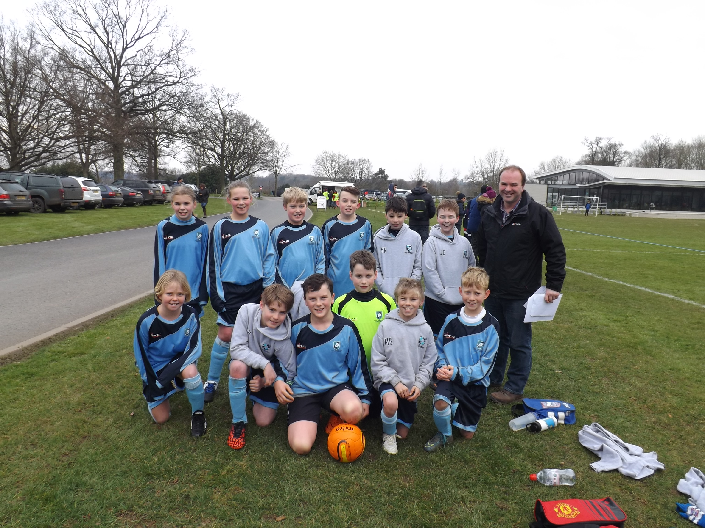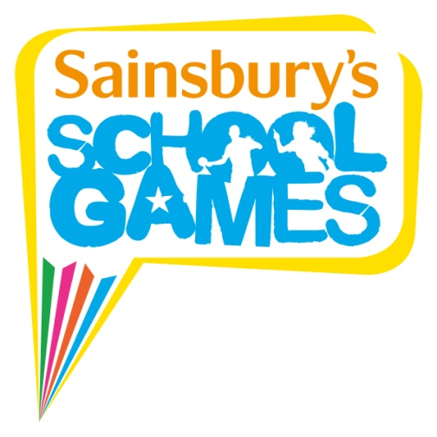

On Wednesday 9th March, our U11 hockey teams played in a tournament at Stowmarket High School. We had three teams that played in the tournament and it was a fantastic effort by all who participated. I am thrilled to announce that two of our teams played against each other in the final and received the gold and silver medals, well done everyone! Both teams went through to play in the Partnership Hockey Finals at Stowmarket High School on Wednesday 16th March, and played fantastically well again. Even though we didn’t win, it was still a fantastic achievement, enjoyed by all!

During the first half of the summer term, we are offering children the chance to take part in a selection of new sporting clubs and activities commencing at the school:

- **Kick Boxercise** with Mr Green from the School Sport Partnership for Year’s 5 and 6.

- **Gymnastics** with Miss Bennett for Year’s 1 and 2.

- **Athletics** with Mr Green from the School Sport Partnership for Year’s 3, 4 and 5.

The final total of money raised as part of our Olympic athlete visit on Monday 7th March was a fantastic amount and I would like to say a big thank you to all that sponsored the children to participate in such an enjoyable and inspiring morning of sporting activities. The children really enjoyed themselves so thank you again.

On Monday 29th February, our Year 6 basketball team took part in the Area Finals tournament at Thurston Community College. The competition was incredibly close and we finished in second place, not quite enough to reach the County Finals but we still played brilliantly, well done everyone, a fantastic achievement!

On Monday 7th March, we welcomed GB Paralympic Footballer Roy Turnham to the school. One of the newer members of the Football 5-a-side team, Roy made his Paralympic debut in London 2012 and was part of the team that finished in 7th place. Roy led a**sponsored fitness circuit with all the pupils** and finished with a talk, and a question and answer session. The children have been raising money as part of the visit and it will be used to buy **sports equipment** for the school, whilst also**supporting GB athletes (including Paralympic athletes). It was a really exciting morning, enjoyed by all!**

On Friday 5th March, our U11 swimming team took part in a swimming gala at Stowmarket Leisure Centre. We entered two teams and each team had to compete in a number of different races using different swimming strokes: front crawl, back crawl, breast stroke and a medley relay. I am delighted to say that one of our teams finished in second place, receiving the silver medal and we also had the fastest swimmer for front crawl out of all the heats, such a great achievement, well done everyone!

On Saturday 27th February, our Year 5 and 6 footballers took part in a 7-a-side football tournament at Finborough School. We played four matches against St Joseph’s, Oakfield, Littlegarth and Edgegrove. They didn’t make it past the group stages but they still had a brilliant day playing some fantastic football in freezing weather conditions!